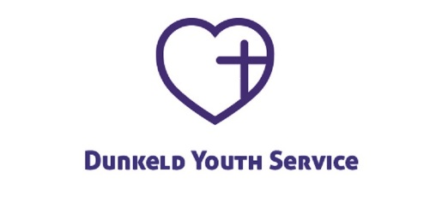
Panama 2019 – World Youth Day (WYD)
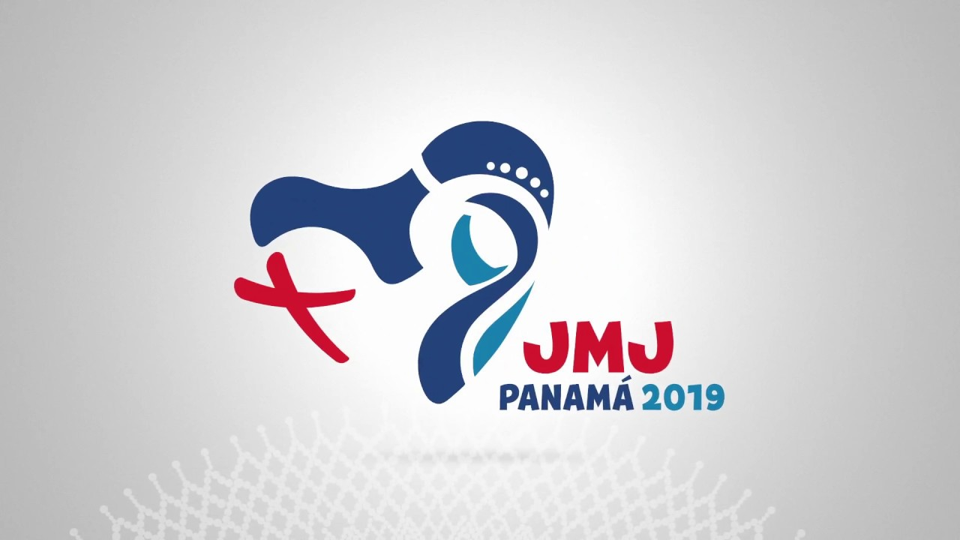
22nd – 27th January, 2019
Expression of Interest
What is WYD?

WYD is celebrated every two or three years by Catholic youths, who gather from all over the world at the invitation of the Pope. This event is an opportunity to experience the universality of the Church and share in the hope of many young people who want to commit themselves to Christ and others.
Previous World Youth Days have drawn and inspired many young Catholics into deepening and witnessing to their faith in Jesus Christ. This is another opportunity!

Theme: “I am the servant of the Lord. May it be done to me according to your word.” Lk 1:38

Are you interested?

If you would like to join the group, please speak to your Parish Priest and complete the form below. Then return as soon as possible to Fr Samuel Alabi, MSP at the Youth office:

Diocesan Office, 24-28 Lawside Road, Dundee, DD3 6XY

What does it cost?

The total cost including: transfers, flights, food, accommodation will be £1500-£2000 per participant. We expect that local parishes will sponsor their young people. In addition, DYS will arrange some fundraising so as to make the cost more affordable.

For more information:

Contact: Fr Samuel Alabi MSP, Director of Youth Formation, at:
youth-office@dunkelddiocese.org.uk or call him on: 07864700495.
.........................................................................................................

Pilgrim (18 or over): _________________________________________________
D.O.B ___________________________ Age: ____

Telephone number:______________________

Email address: ______________________________________________________

Address: __________________________________________________________
_________________________________________ Postcode:________________

Parish: ____________________________________________________________

I confirm that I would like to join the WYD Panama 2019 group.
Signed_______________________ Print___________________ Date__________

